Node MCU Functionalities

Node MCU

( Server + Micro controlling)

Web Application

MQTT Server

NTP Server

Motor Controller

Fig: Connectivity diagram between Node MCU and other blocks.

Web Application and Node MCU

HTTP request

HTTP reply

Webserver

(Node MCU)

Webpage

(User)

Webserver is implemented in the Node MCU.

According to the HTTP requests sent by the user, operations are carried out.

* Location set up data sent by the user is sent to the Node RED and receive the weather details.
* Received weather data sent to the webpage.
* According to the selected method, watering is done.

Webpage is designed using HTML, CSS and JavaScript.

User commands is sent to the Node MCU as HTTP requests.

* User sets up the location and send it to the Node MCU.
* User can set up the watering mode to either AUTO or MANUAL.

A Clock will be running in order to synchronize the sleeping schedule with the Node MCU. This will be further discussed later.

Webpage

When set to MANUAL , this can be used to manually water the plants

Toggle between AUTO and MANUAL

To set up the location

Current Location Weather Details

MQTT Server and Node MCU

Location of the garden (City- Country) is sent to the Node Red through the MQTT server.

MQTT broker sends the published data from Node Red to the Node MCU. These data packets include the Temperature, Humidity, Weather type (Rain, Clouds, Sunny…), and the time zone of the garden.

NTP Server and Node MCU

NTP server is used to get the UTC time and a local clock runs on the Node MCU. Local time is calculated using the time zone information ( how much time needs to be added to the UTC) sent by the NodeRed.

Node MCU Server

Server runs on the Node MCU and it is accessible only inside the Local network because router doesn’t have a public IP. This server contains the web page information, and it is capable of handling Get, Push, …… Requests. In this application we only use Get request and their responses to maintain the system.

Node MCU - Micro Controller

At the same time, Node MCU act as the micro controller of the watering system. Using collected data, it decides water or not, mode of watering and when to water. Additionally, it will sleep occasionally and wake up and rebuild connections automatically. This mechanism helps to reduce the power consumption.

This system has two watering modes. Switching between these two modes can be done only when the Node MCU is awake.

MANUAL

User has the full authority to control the watering. When he presses the watering button once, system waters for 5 minutes.

No sleeping mechanism implemented because user has the full control of the system.

AUTO

Watering happens twice a day, between 9am-10am and 4pm – 5pm, for a calculated time period.

$$watering time=\frac{temp}{10}+\frac{(100-hum)}{30} mins$$

Watering will not happen if the weather type is Rain or Storm.

Sleeping Schedule

Node MCU goes to its light sleep mode at (2, 8, 14, …, 57) minutes in every hour. It sleeps for 3 minutes wake up in (0, 6, 12, …, 54) minutes in every hour. Briefly Sleep- Awake mechanism has a 6 minute time period. It awakes in first 3 minutes and sleeps in the second 3 minutes.

After watering happens, it automatically falls back to the sleeping schedule.

Motor Controller

When watering happens, Node MCU make its Valve (D4) pin High. This signal is given to a LM298n motor driver module and it switches on the 12V DC water valve.

Node MCU

Motor Controller

DC Valve

**D4 High / Low**

**ON / OFF**

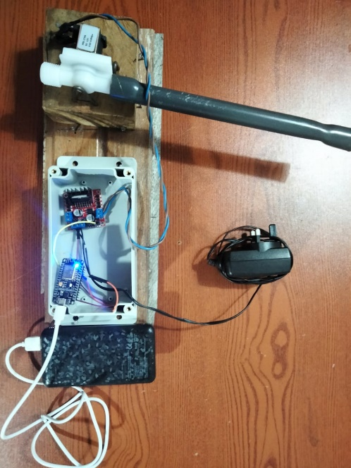

Fig: Hardware setup of the system